## National University of Computer & Emerging Sciences, Karachi

**Computer Science Department Spring 2024, Lab Manual – 01**

|  |  |
| --- | --- |
| **Course Code: CL-217** | **Course : Object Oriented Programming Lab** |
| **Instructor(s) :** | **Ali Fatmi** |

LAB - 1 INTRODUCTION TO JAVA

**JAVA**

Java is a high-level programming language originally developed by Sun Microsystems and released in 1995. Java runs on a variety of platforms, such as Windows, Mac OS, and the various versions of UNIX. James Gosling initiated the Java language project in June 1991.

Java can be used to create two types of programs: applications and applets. An application is a program that runs on your computer, under the operating system of that computer. An

applet is an application designed to be transmitted over the Internet and executed by a Java compatible Web browser.

**TYPICAL JAVA DEVELOPMENT ENVIRONMENT**

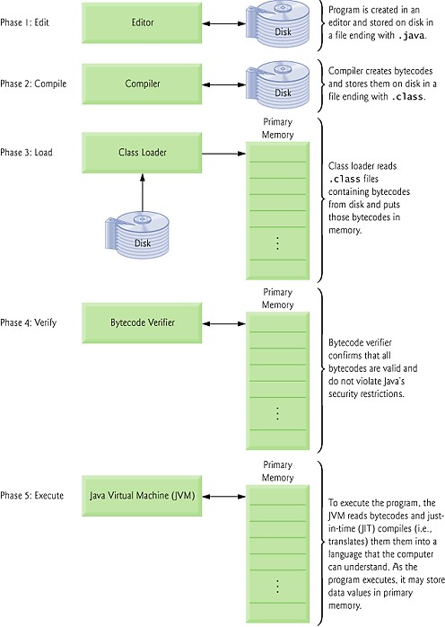

**Phase 1: Creating a Program**

Phase 1 consists of editing a file with an editor program. You type a Java program (typically referred to as source code) using the editor, make

any necessary corrections and save the program. A file name ending with the .java extension indicates that the file contains java source code.

**Phase 2: Compiling a Java Program into Bytecodes**

The Java compiler compiles a program. If the program compiles successfully, the compiler produces a .class file. The Java compiler translates Java source code into bytecodes. Bytecodes are executed by the Java Virtual Machine

(JVM).

**Phase 3: Loading a Program into Memory**

The JVM places the program in memory to execute it—this is known as

loading.The JVM’s class loader takes the .class files containing the program’s bytecodes and transfers them to primary memory.

**Phase 4: Bytecode Verification**

The classes are loaded, the bytecode verifier examines their bytecodes to ensure that they’re valid and do not violate Java’s security restrictions.

**Phase 5: Execution**

The JVM executes the program’s bytecodes, thus performing the actions specified by the program.

# Difference between JDK, JRE, and JVM

#### JVM

JVM (Java Virtual Machine) is an abstract machine. It is called a virtual machine because it doesn't physically exist. It is a specification that provides a runtime environment in which Java bytecode can be executed.

JVMs are available for many hardware and software platforms. JVM, JRE, and JDK are

platform dependent because the configuration of each OS is different from each other. However, Java is platform independent.

The JVM performs the following main tasks:

* Loads code
* Verifies code
* Executes code
* Provides runtime environment

#### JRE

JRE is an acronym for Java Runtime Environment. The Java Runtime Environment is a set of software tools which are used for developing Java applications. It is used to provide the runtime environment. It is the implementation of JVM. It physically exists. It contains a set of libraries + other files that JVM uses at runtime.

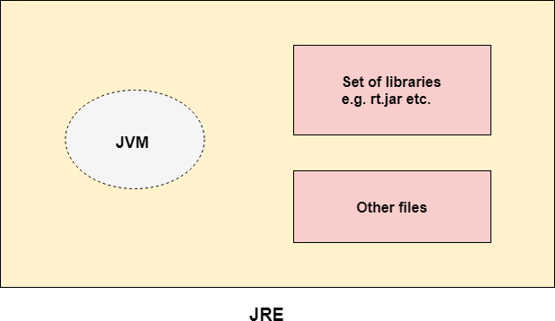

#### JDK

JDK is an acronym for Java Development Kit. The Java Development Kit (JDK) is a software development environment which is used to develop Java applications and applets. It physically exists. It contains JRE + development tools.

The JDK contains a private Java Virtual Machine (JVM) and a few other resources such as an interpreter/loader (java), a compiler (javac), an archiver (jar), a documentation generator (Javadoc), etc. to complete the development of a Java Application.

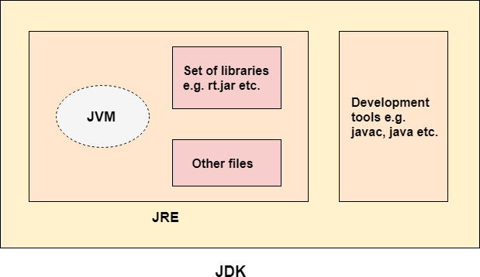

**IDE:**

NetBeans is an integrated development environment (IDE) for Java. NetBeans allows

applications to be developed from a set of modular software components called modules. NetBeans runs on Windows, macOS, and Linux. In addition to Java development, it has extensions for other languages like PHP, C, C++, HTML5, and JavaScript.

#### INSTALLATION GUIDE TO NETBEANS:

To download the latest version of netbeans, use the following link: <https://netbeans.apache.org/download/index.html>

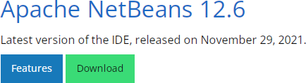

Click on Download and then select the desired option based on your OS:

If 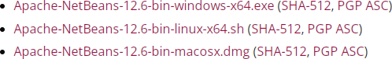

Windows is selected, you will be redirected to another page. Click on the link to download

the .exe file.



Run the .exe file to setup Netbeans on your systems.

If incase, you are prompted that JDK is not found on your computer, please vist the following link to download it on your computer.

[https://www.oracle.com/java/technologies/downloads/#jdk17-windows](https://www.oracle.com/java/technologies/downloads/)

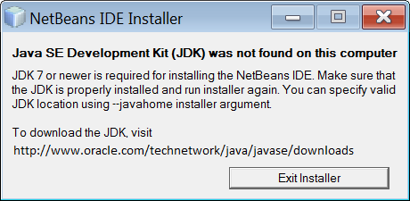

Download the Installer file based on your OS. Run the .exe file to setup JDK on your computer and then install NetBeans.

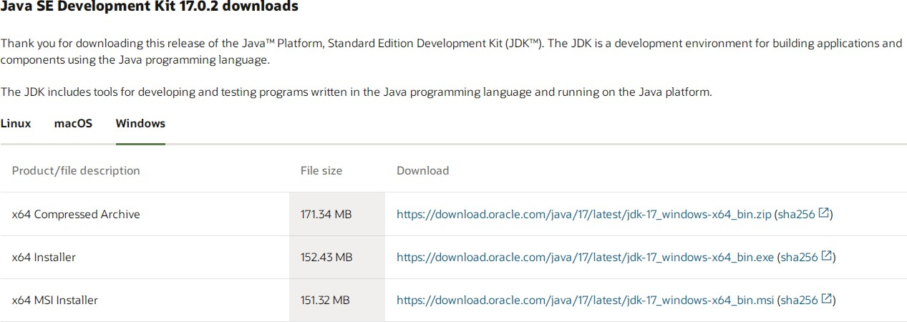

#### USING NETBEANS:

LAB#01:INTRODUCTION TO JAVA

6

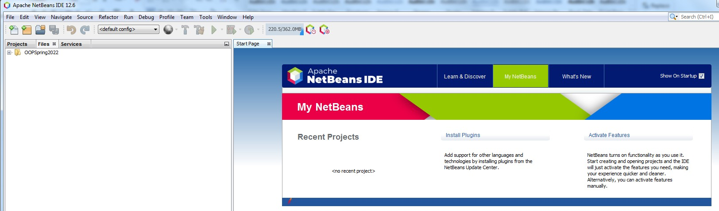

Use the shortcut on your Desktop to open NetBeans.

This is the first screen that appears when you open NetBeans.

#### CREATING A PROJECT IN NETBEANS

Click on File – New Project

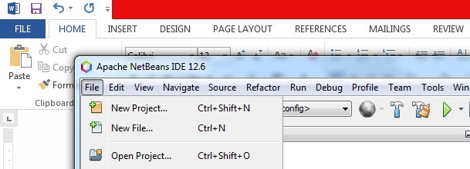

## Java Build Tools

**Maven**

Apache Maven is a powerful software project management tool used in the Java development environment to manage and build projects as well as to maintain dependencies. Maven uses an XML (pom.xml) for project configuration.

## Gradle

Gradle is a modern automation tool used in software development for project build automation. Gradle has its own domain-specific language (DSL) based on a Groovy

(build.gradle) or Kotlin (build.gradle.kts) code.

## Ant

Apache Ant is the predecessor of Apache Maven. First released in 2000, Ant was developed as a replacement for a build tool Make, which was used widely in software development in the past. Using an XML file, Ant is used to automatize build tasks.

Click on Java Maven, then Java Application

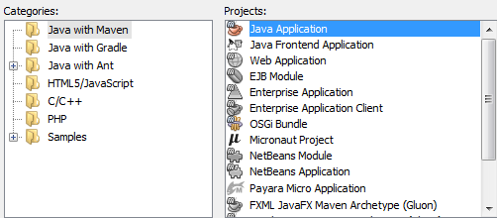

Write down your Project Name.

You can also choose a project location. Here we are using the default location.

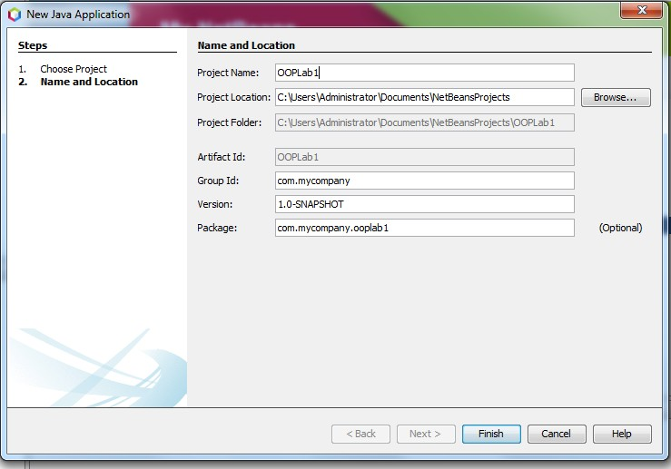

Once you click Finish, a project directory will be automatically created as seen in the Projects panel.



#### CREATING A JAVA CLASS

Right click on source packages – New – Java Class

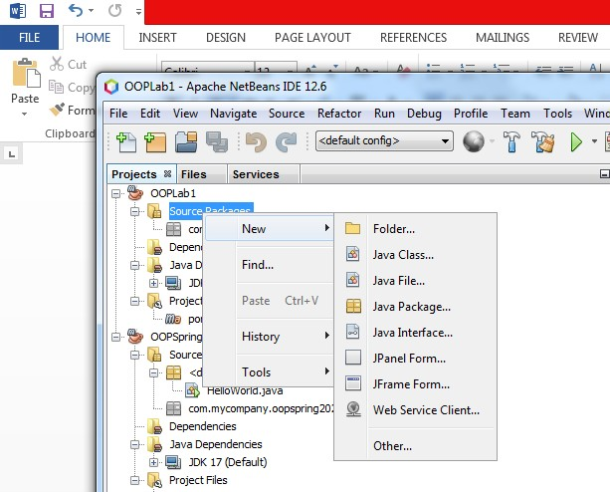

Once you click on

Java Class, a window pops up. Write down a class name and choose the correct package that is present in source packages.

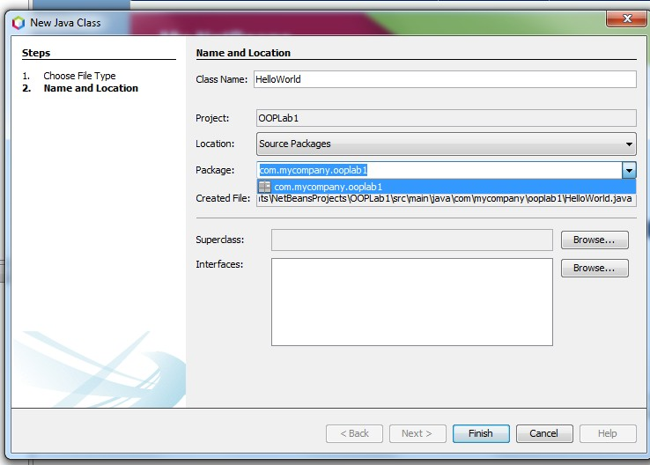

After Finish, a class is created.

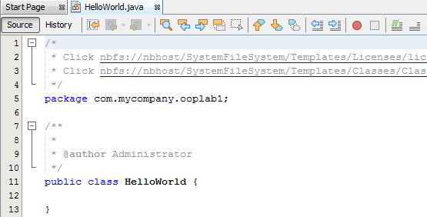

Now let’s create a simple program.

// MyFirstProgram **In Java, any line starting with // is a comment.**

#### public class HelloWorld { In Java, every application begins with a class definition. In the program, HelloWorld is the name of the class. Every Java application has a class definition, and the name of the class should match the filename in Java.

public static void main(String[] args) { **This is the main method.**

#### class keyword is used to declare a class in Java.

* **public keyword is an access modifier that represents visibility.**

#### static is a keyword. The advantage of the static method is that there is no need to create an object to invoke the static method.

* **The main() method is executed by the JVM, so it doesn't require creating an object to invoke the main() method. So, it saves memory.**

#### void is the return type of the method. It means it doesn't return any value.

* **main represents the starting point of the program.**

#### String[] args means an array of sequence of characters (Strings) that are passed to the "main" function.

* **When you execute a Java program via the command line: java MyProgram “This is just a test” Therefore, the array will store: ["This", "is", "just", "a", "test"]**

System.out.println("Hello, World!"); **System is a class, out is an object of the PrintStream class, println() is a method of the PrintStream class.**

} }

#### EXECUTING YOUR PROGRAM

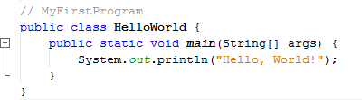

Build

your project.

Click on Run – Build Project (OOP Lab1)

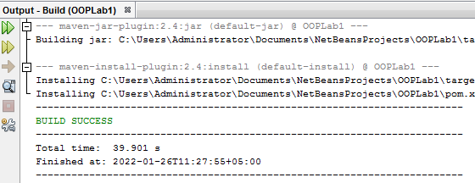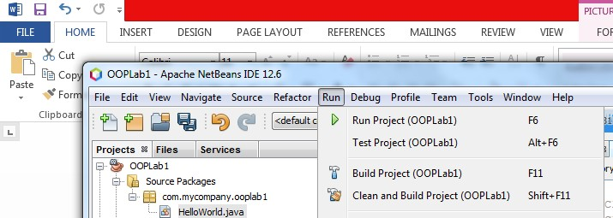

If

Build is successful, the output screen displays the following message:

To run your file click on the green arrow, and then select the main class and remember in Current IDE Session.

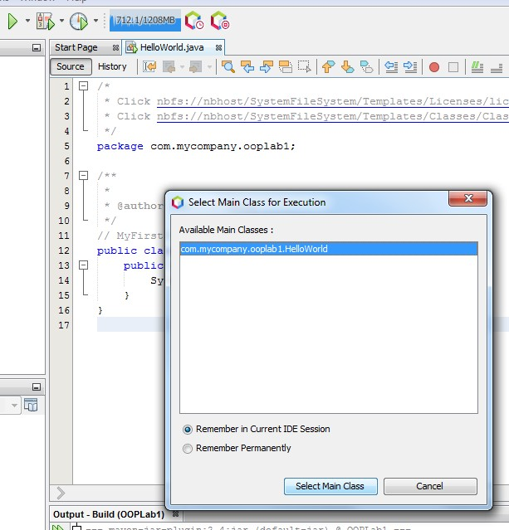

The output

is displayed in the output window.

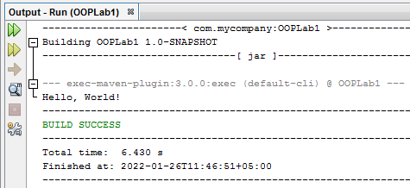

## DATA TYPES

Data types are divided into two groups:

Primitive data types - includes byte, short, int, long, float, double, boolean and char Non-primitive data types - such as String, Arrays and Classes

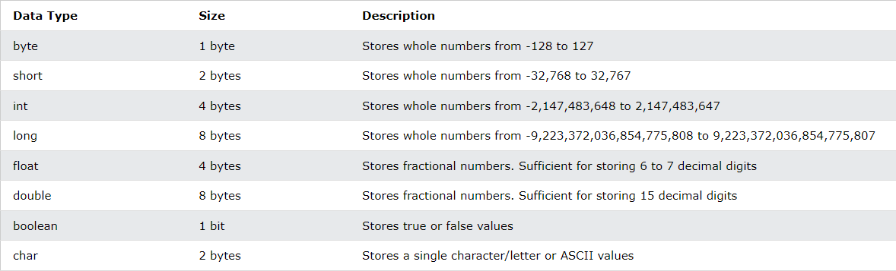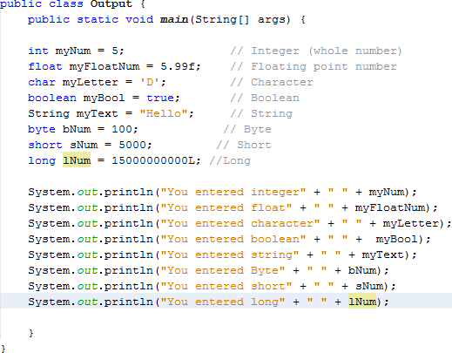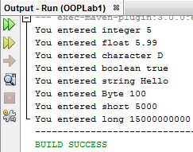

## INPUT AND OUTPUT IN JAVA

#### Java output:

In Java, you can simply use **System.out.println(); or System.out.print(); or System.out.printf();**

to send output to standard output (screen). Here, System is a class out is a public static field: it accepts output data.

Difference between println(), print() and printf()

* + print() - It prints string inside the quotes.
  + println() - It prints string inside the quotes similar like print() method. Then the cursor moves to the beginning of the next line.
  + printf() - It provides string formatting (similar to printf in C/C++ programming).

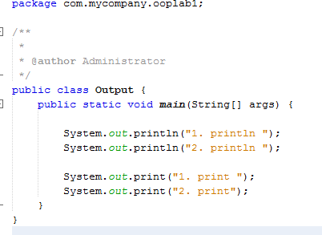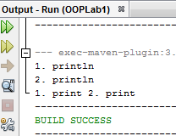

## FORMATTING OUTPUT WITH PRINTF() IN JAVA

Conversion characters are only valid for certain data types. Here are some common ones:

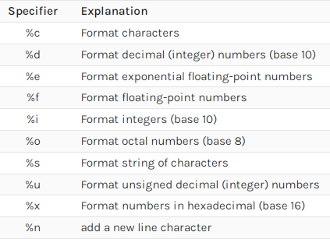

#### Float and Double Formatting

To format a float number, we'll need the f format:

#### System.out.printf("%f%n", 5.1473); which will output: 5.147300

To control the precision: **System.out.printf("'%5.2f'%n", 5.1473);** Here we define the width of our number as 5, and the length of the decimal part is 2: **' 5.15'.**

#### Integer Formatting

The printf() method accepts all the integers available in the language — byte, short, int, long, and BigInteger if we use %d:

#### System.out.printf("simple integer: %d%n", 10000L);

With the help of the d character, we'll have this result: **simple integer: 10000**

#### String Formatting

To format a simple string, we'll use the %s combination. Additionally, we can make the string uppercase:

printf("'%s' %n", "Java");

printf("'%S' %n", "JAVA");

And this is the output: 'Java'

'JAVA'

#### Char Formatting

The result of %c is a Unicode character: System.out.printf("%c%n", 's');

System.out.printf("%C%n", 's');

The capital letter C will uppercase the result: s

S

## Input from user in Java

Java Scanner Class

Java Scanner class allows the user to take input from the console. It belongs to java.util package.

Syntax

***Scanner sc = new Scanner(System.in);***

The above statement creates a constructor of the Scanner class having System.in as an

argument. It means it is going to read from the standard input stream of the program. The java.util package should be imported while using Scanner class.

Methods of Java Scanner Class

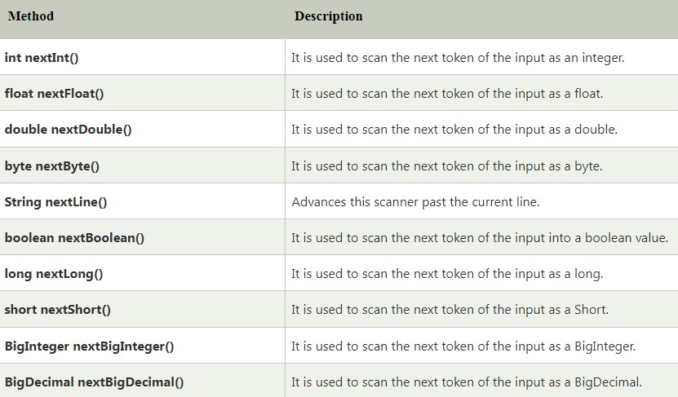

#### Example: Input your name

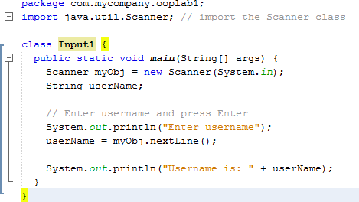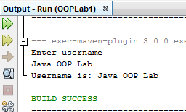

**Example: Input integers**

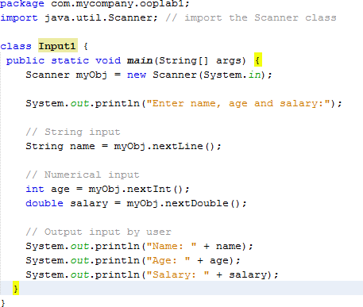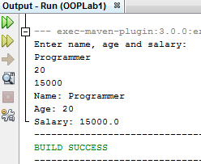

#### Example: Adding two numbers

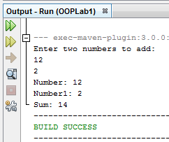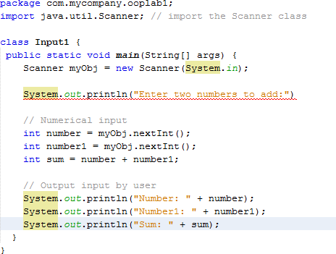

**Java Arrays**

String[] cars;

String[] cars = {"Volvo", "BMW", "Ford", "Mazda"};

int[] myNum = {10, 20, 30, 40};

String[] cars = {"Volvo", "BMW", "Ford", "Mazda"};

System.out.println(cars[0]);

cars[0] = "Opel";

String[] cars = {"Volvo", "BMW", "Ford", "Mazda"};

cars[0] = "Opel";

System.out.println(cars[0]);

String[] cars = {"Volvo", "BMW", "Ford", "Mazda"};

System.out.println(cars.length);

**Java Multi-Dimensional Arrays**

int[][] myNumbers = { {1, 2, 3, 4}, {5, 6, 7} };

int[][] myNumbers = { {1, 2, 3, 4}, {5, 6, 7} };

System.out.println(myNumbers[1][2]); // Outputs 7

int[][] myNumbers = { {1, 2, 3, 4}, {5, 6, 7} };

myNumbers[1][2] = 9;

System.out.println(myNumbers[1][2]); // Outputs 9 instead of 7

public class Main {

public static void main(String[] args) {

int[][] myNumbers = { {1, 2, 3, 4}, {5, 6, 7} };

for (int i = 0; i < myNumbers.length; ++i) {

for(int j = 0; j < myNumbers[i].length; ++j) {

System.out.println(myNumbers[i][j]);

}  
 }

}

}

**Dynamic Array in Java**

public class InitializeDynamicArray

{

public static void main(String[] args)

{

//declaring array

int array[];

//initialize an array

array= new int[6];

//adding elements to the array

array[0] = 34;

array[1] = 90;

array[2] = 12;

array[3] = 22;

array[4] = 9;

array[5] = 27;

System.out.print("Elements of Array are: ");

//iteraton over the array

for(int i=0; i< array.length ; i++)

{

System.out.print(array[i] +" ");

}

}

}

**LAB#01 EXERCISES**

**QUESTION#1**

Write a program that calculates how long it takes to drive from Karachi to Lahore at 75 mile per hour (Use 3000 miles as the approximate distance between two cities).

### QUESTION#2

1. Write an application that accepts two doubles, multiple these together and display the product.
2. Write a Program to print the area of a triangle.

### QUESTION#3

Write a Java program that works as a simple calculator for the +, -,*, / operations. Take two integer numbers from the user and perform all the four operations.

### QUESTION#4

Write a Java program that prints all real solutions to the quadratic equation ax2 + bx + c = 0. Read in a, b, c and use the quadratic formula.

### QUESTION#5

Write a Java program that inputs three integers from the user and displays the sum, average, and product of these numbers.

### QUESTION#6

Write a Java program that inputs from the user the radius of a circle as an integer and prints the circle’s diameter, circumference and area using the floating-point value 3.14159 for π.

### QUESTION#7

Write a Java program that takes as input your name, student ID, current courses registered for and displays all the information.

### QUESTION#8

Write a Java program to find the largest and smallest elements in an array of integers. Implement a loop to iterate through the array and print both the largest and smallest elements.

### QUESTION#9

Create a Java program that simulates a 2D game board represented by a 2D array. Implement a loop to fill the board with player symbols (e.g., 'X' and 'O'). Then, check if there is a winner by examining rows, columns, and diagonals for matching symbols.

### QUESTION#10

Implement a dynamic array class in Java (you can use ArrayList or create your own resizable array). Then, write a program that reads list of names and dynamically stores them in the array. Finally, use a loop to iterate through the array and print the names in reverse order.